Sample format C FORMS LOST AD
This is the format for an ad where C forms are lost. Charges for such ads are usually 890/- in 2 Newspapers. Kindly make the changes with your details in the below matter and resend it back to us on classic_advt@hotmail.com
NOTICE is hereby given that the following C Forms issued by M/s Mayank Granites in the name of M/s Vatsal Enterprises & M/s Vatsal Granites have been misplaced and not traceable. If found inform to M/s Mayank Granites. Plot no. 2232-2234, Marve Rd, Near Bageecha Hotel, Malad West, Mumbai – 95

1) Vatsal Enterprises
C From no.: MH - 12/A - 514089 Period
01/07/2012 to 30/09/2012 Amount 129377/-
2) Vatsal Granites
C Form No.: MH - 12/A 514090 Period
01/07/2012 to 30/09/2012 Amount 389414/-

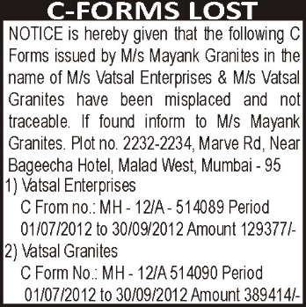

Charges : 890/- in 2 Newspapers

